**Commerce Notifications Application**

**Group 2**

April 26, 2020

**Team Members**

Kory Overbay

Matt Hopkins

Connor Marchand

Jimin Choi

# **Contents**

1 Introduction............................................................................................................................. 3

2 Quick Start Guide......................................................................................................................................... 3

3 System Requirements............................................................................................................................ 4

4 Main Scenarios of Use............................................................................................................................................ 5

5 Troubleshooting...................................................................................................................... 8

# 

# 

# 

# 

# **1 Introduction**

The Commerce Notifications App will allow users to securely login to their Commerce account and to see if any of their transactions have raised notification warnings. Warnings could be suspicious activity such as purchases late at night or purchases in another state. Notifications could also help a customer budget by displaying purchases over a certain amount. For testing and demonstration purposes the user may also add a new transaction to see if it triggers a notification.

# **2 Quick Start Guide**

Users connect to the website through their personal computer or phone.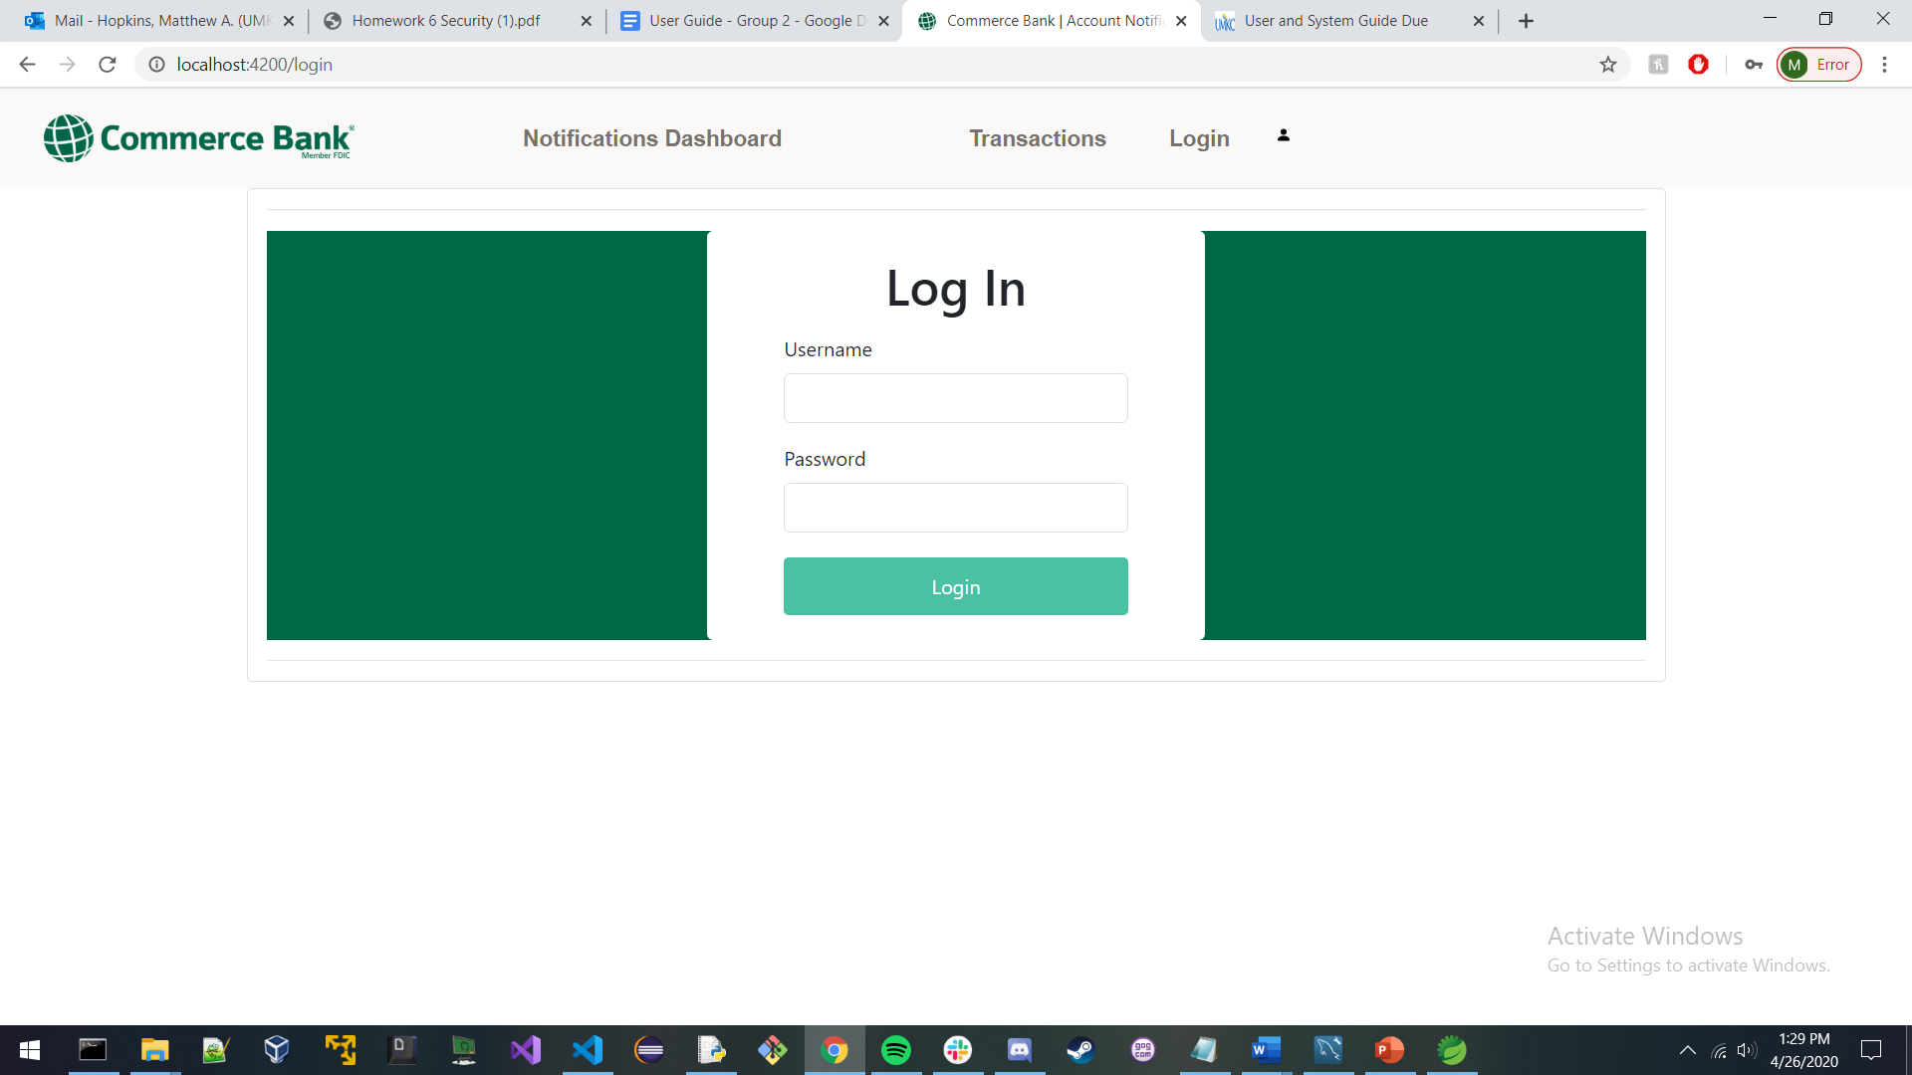

User enters their correct Username and Password and presses Login button

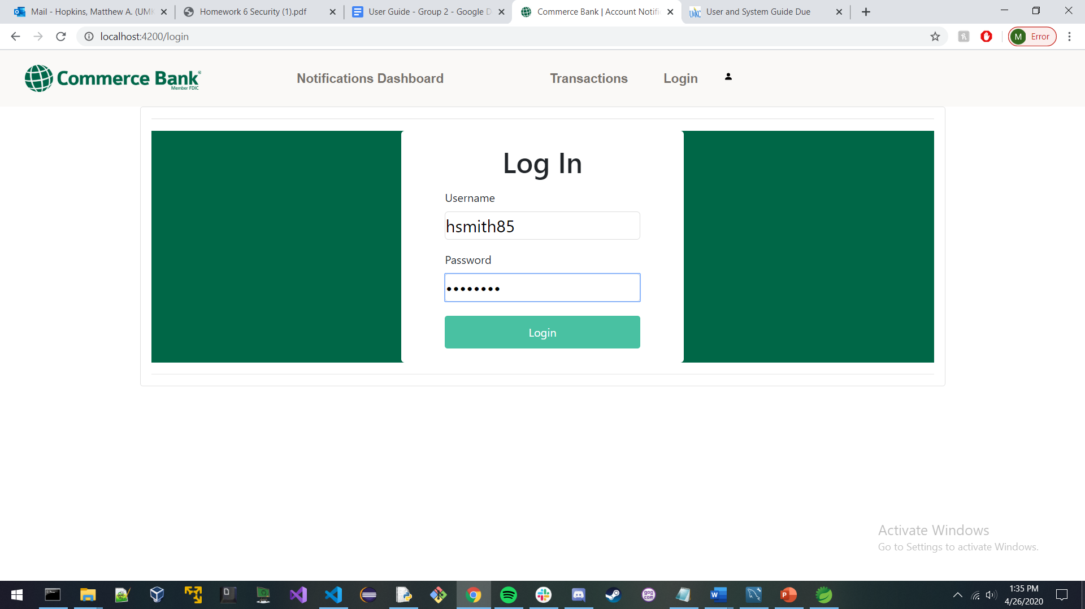

User is brought to the notifications dashboard where they can see any of their selected notifications by pressing the Search button

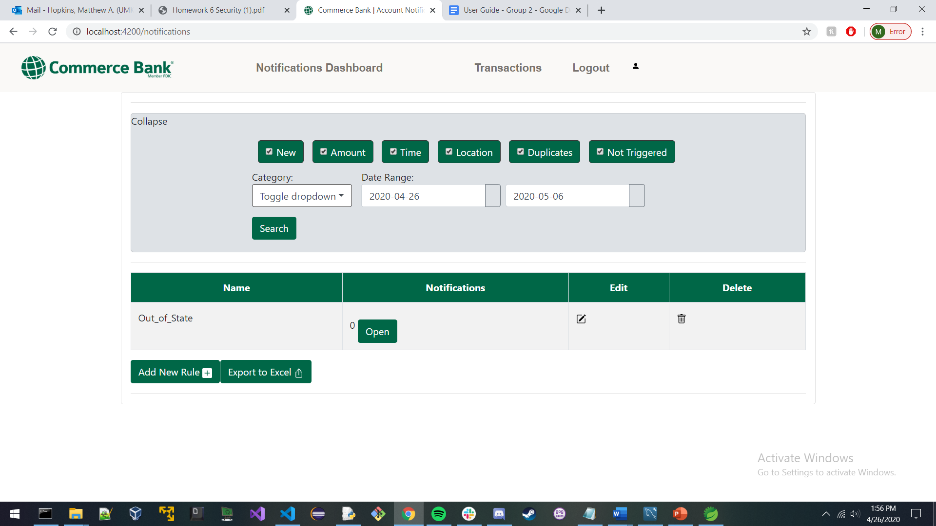

User can click on the Transaction button to view recent transactions on their account

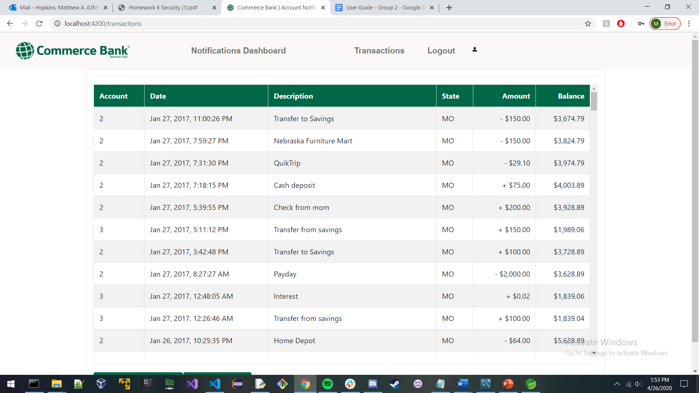**3 System Requirements**

* Smartphone or Tablet
* Personal Computer

# 

# **4 Main Scenarios of Use**

## **4.1 User Logs in**

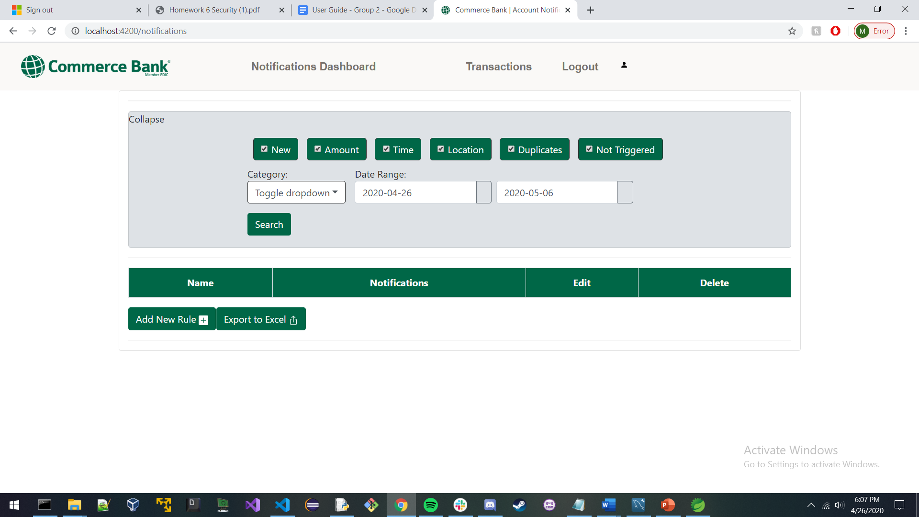

User has just logged into the Commerce Notifications App

## **4.2 User Adds New Rule Notification**

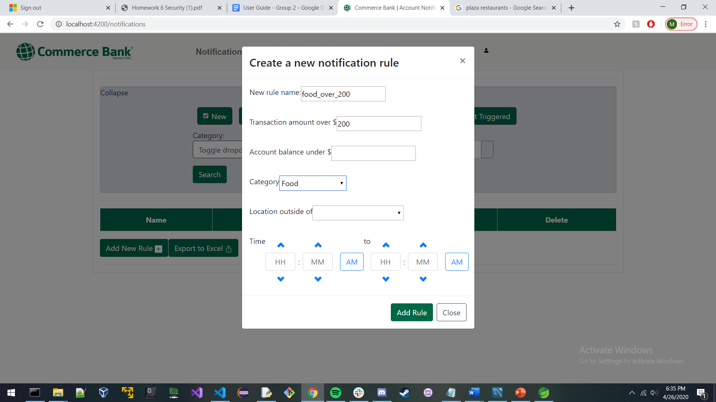

User creates a new rule. In this example the User is interested in seeing any transaction that are over $200 and are in the category “Food”

## **4.3 User Checks Transactions**

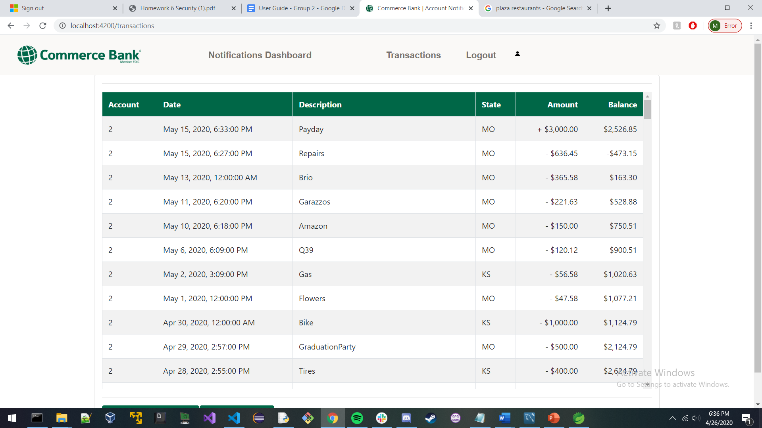

User clicks on the Transactions button

## **4.4 User Adds New Transactions**

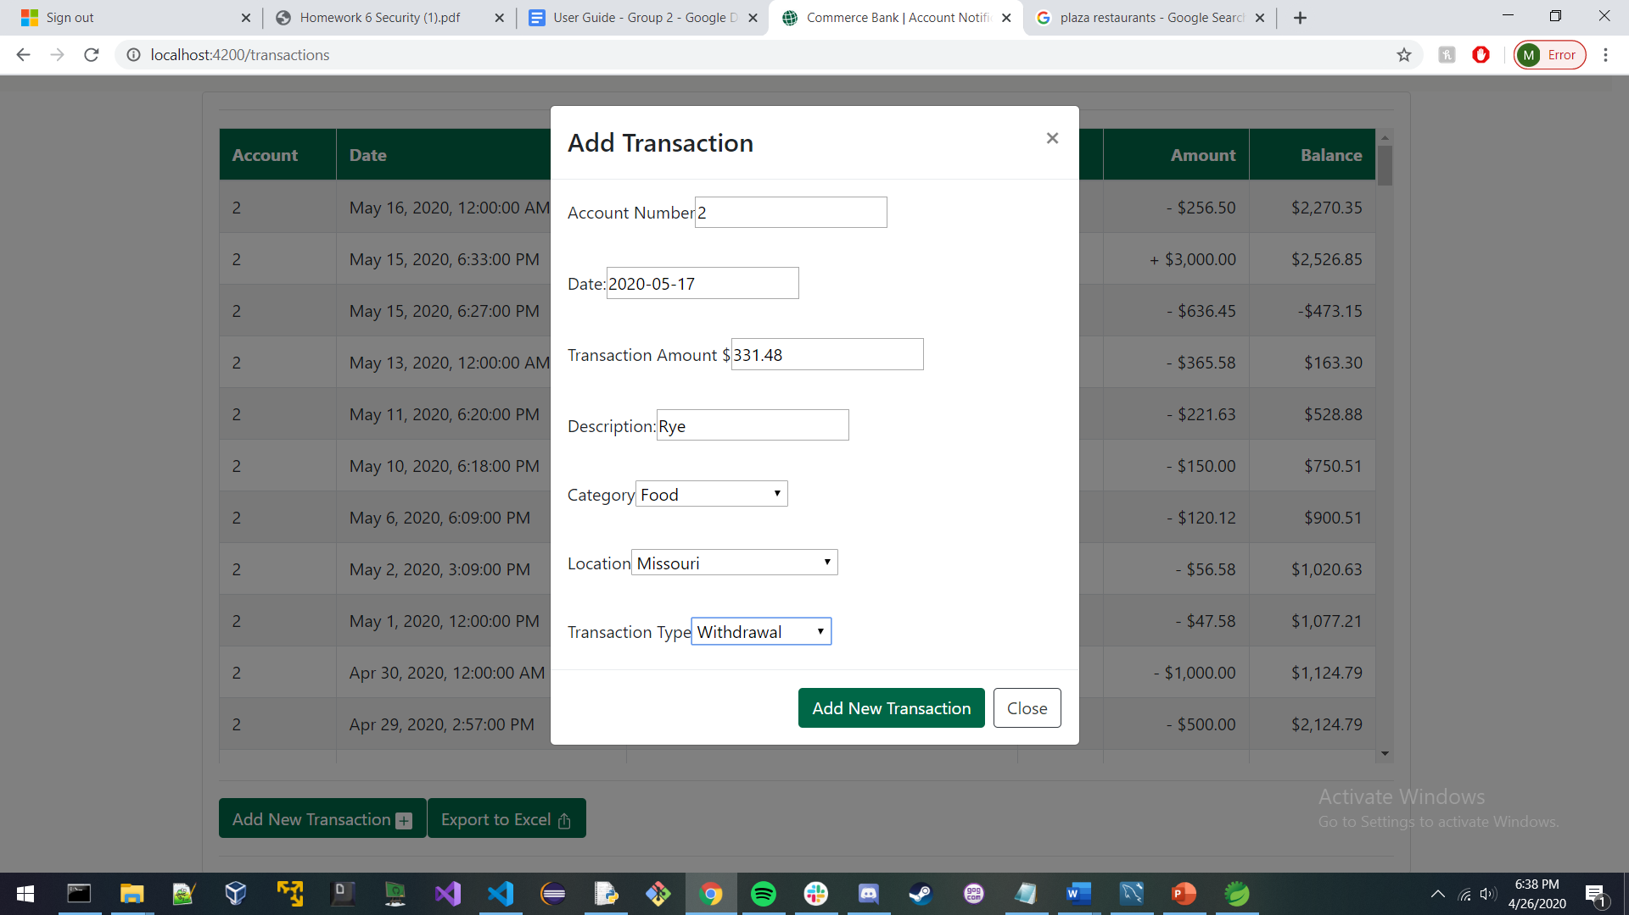

User clicks on the Add New Transaction button. User then fills out all of the forms and then clicks on the Add New Transaction button.

## **4.5 User Checks If New Transaction Triggered Notification**

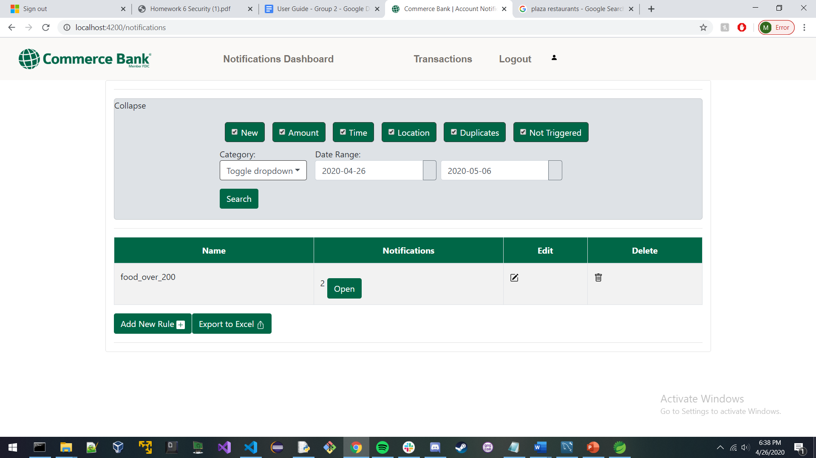

User navigates back to the Notifications Dashboard and then clicks the Search button.

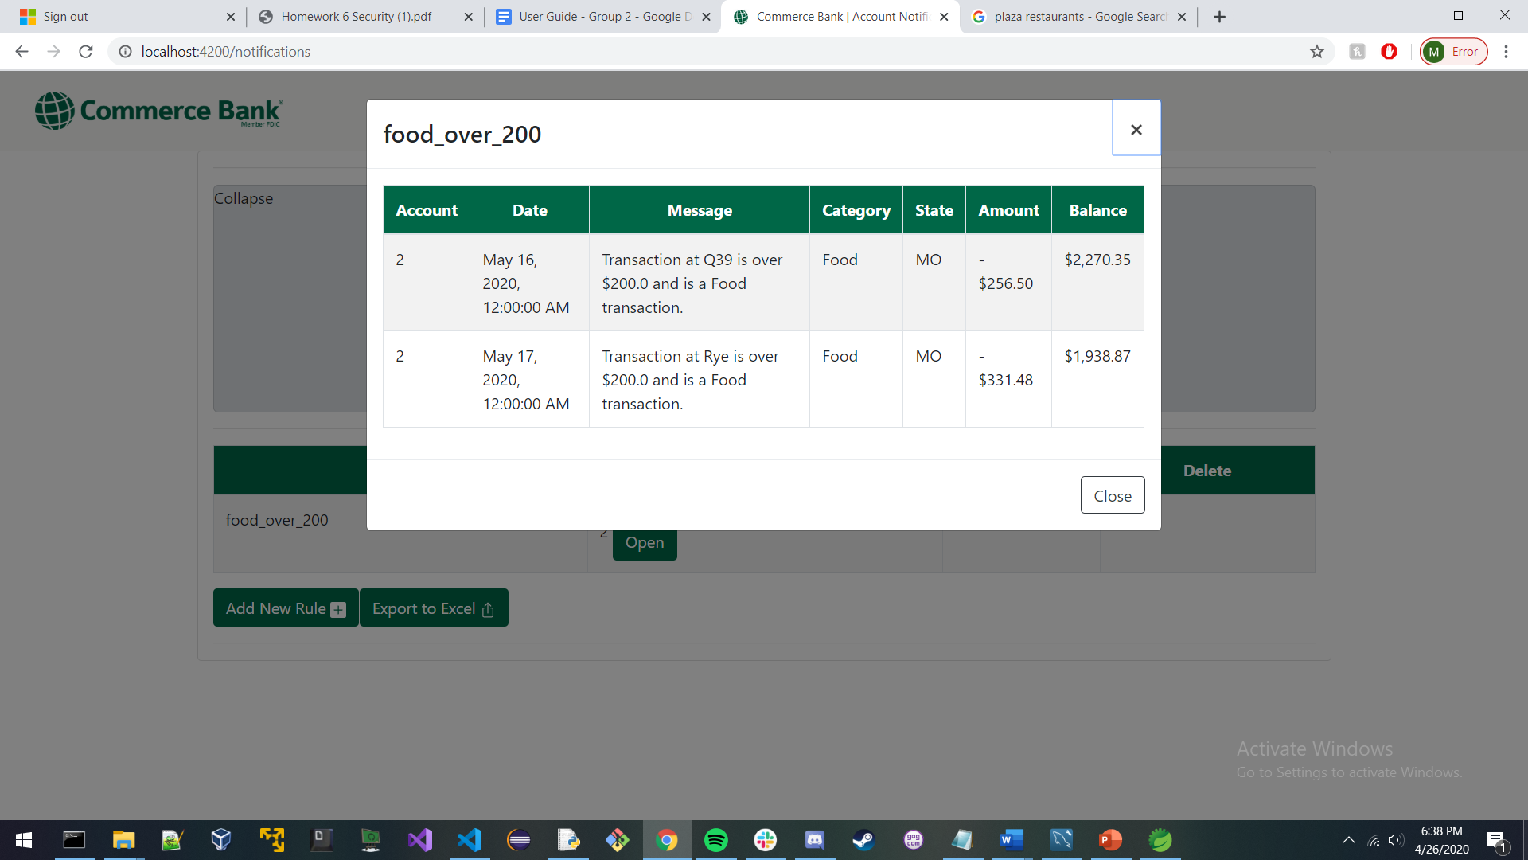

User then clicks on the Open button which will show all new transactions that have triggered their notification.

**5 Troubleshooting**

## **5.1 Missing or Incorrect Password**

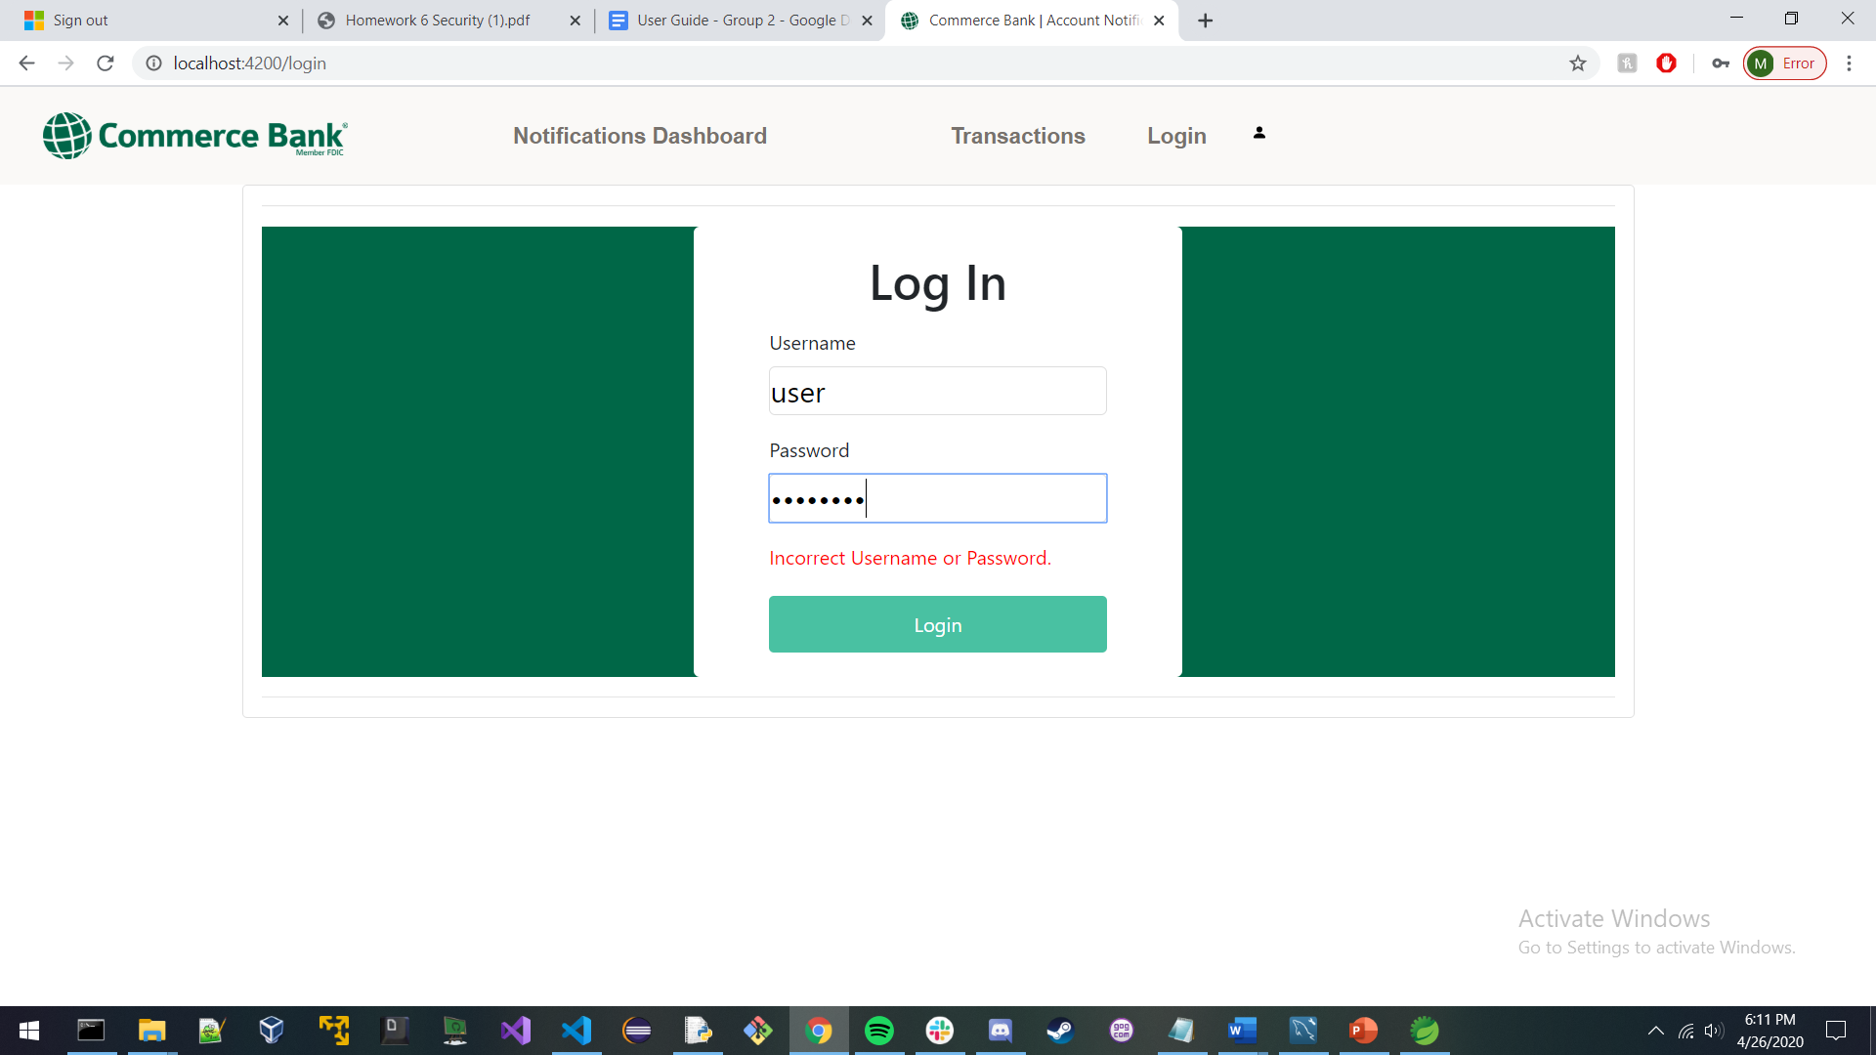

User has logged in either with the incorrect username or password. User does not gain access to the website and is informed they have entered an incorrect field.